Structure of Dissertation Proposal

1. Abstract
2. Introduction
   1. Literature Review?
3. Study 1 – Current Summer Data + Fall
   1. Method
   2. Results
   3. Discussion
4. Study 2 – Future study ideas??
   1. Method
   2. Results
   3. Discussion
5. Study 3 – Lets figure out what other ideas we can have
   1. Method
   2. Results
   3. Discussion
6. Overall Discussion
7. Limitations
8. Future Directions
9. Appendices
10. References

Abstract?

* Think about where we are going with study 2 and 3 before we write this up entirely.
* Partly needs to be based on our final results as well.

**Introduction:**

The United States is the world leader in many things, such as nuclear power generation and yearly military expenditure (CITE). However, the United States is the only country in the developed world that still lacks Universal Health Care (UHC) for its citizens (Alspaugh 2021). This lack of medical coverage results in several strongly negative outcomes for average Americans, such as life expectancy significantly below the global average, 78.8 compared to 81.7 years (Papanicolas, Woskie, and Jha 2018). This lack of UHC does not even result in a cost savings, with healthcare costs continuing to rise. US Healthcare expenditures topped 18.3% GDP in 2021, up from 17.8% in 2016, and both numbers are significantly higher than peer GDP expenditures ranging from 9.6% to 12.4% (*National Health Expenditures*, July 2023). These poor outcomes come as no surprise; The US bears a staggering un-insurance and underinsurance rate combining at over 30% of the total US population (Himmelstein et al. 2005; Roco 2014; Schoen et al. 2005).

A practical answer to these concerns, adopted by many peer countries, is the concept of Universal Health Care (UHC). UHC has historically led to lower overall healthcare costs over time, lower mortality and better overall population health, and is seen by some as more morally or ethically justifiable as compared to privatized health care (William C. Hsiao, Cheng, and Yip 2019; Panpiemras et al. 2011; Galvani et al. 2017; *Making Fair Choices on the Path to Universal Health Coverage*, 2014). However, public perception in the United States is generally negative towards UHC, with recent polling indicating that only 36% of Americans believe that the government should implement UHC.

Considering the obvious benefits to UHC, this begs the question; What is the reasoning behind this lack of relative support, and what can be done to address this? The goal of this project is to examine what types of logical and ethical reasoning are used by individuals resulting in a lack of support for UHC, as well as what types of interventions can interact with these various reasons. Ideally, by assessing how and why people do not support UHC, we can design interventions to improve its public perception.

**Ethics of Healthcare**

Looking at academic literature more broadly, we attempted to build a rough theory behind the reasoning for lack of support for UHC. Taking from the field of ethics research more generally, Brady and Wheeler (1996) posited that moral and ethical choices can fall under two general forms of reasoning, Utilitarian reasoning, and Deontological reasoning. Utilitarian reasoning has a very simple definition, which is seen as “The tendency to assess ethical situations in terms of their consequences for people”; in essence, a pure utilitarian that doesn’t consider other frameworks when making ethical judgements would proscribe to the idea that “the ends justify the means” in all cases. In contrast, Deontological beliefs comprise “the human tendency to assess ethical situations in terms of their consistent conformity to patterns of rules or other formal features”, this can include structures such as ‘rights’, ‘ideals’, and explicitly recorded law; in essence, a pure deontologist would believe that an action is wrong or right based on the nature of why the action was engaged in, not necessarily it’s consequences.

With regards to considering both moral frameworks as they apply to healthcare, we can see as an example how both utilitarian and deontological reasoning are weighed against each other during outbreaks of disease (Tseng, 2021). This is extremely pertinent given the recent COVID-19 pandemic. In setting policy priorities, deontological and utilitarian reasoning bore itself out with regards to which stakeholders are centered in the decision-making itself. For example, policymakers with strong deontological ethics in this case were inclined to be patient centered. Thus the patient’s ‘right’ to bodily autonomy allows for patients to refuse an mRNA vaccine, and any restrictions on those who have not been vaccinated are seen as potentially unjust under the circumstances. While it is possible that there would be great benefits to society as a whole if vaccinations were mandatory across society, this strongly violates the ‘right’ to bodily autonomy, and would be seen as unacceptable through a deontological ethical lens. In contrast, policymakers that prioritize utilitarianism, are generally inclined to be society centered, which values care that provides the greatest welfare for the greatest amount of people. Seen from this perspective, mandatory vaccinations, as they would result in generally better levels of societal health, would be ethically justifiable, even if it would result in the trampling over of individual bodily autonomy. Indeed, the path to reaching the greatest happiness for the most people could very well result in the wholesale sacrifice of a small, but significant number of complete innocents. In a practical sense, most stakeholders in non-emergency healthcare scenarios generally attempt to balance both deontological and utilitarian ethical concerns.

Another circumstance to assess ethical justification behind medical decision-making comes from the perspective of disaster triage (Wagner, 2015). While it is self-evidence that medical resources are definitionally limited, this is taken to an extreme degree during emergency service disaster triage situations. In these circumstances, individual professionals are forced to make life or death decisions, wherein patients that are critically injured with minimal chance of survival (e.g. major blood loss, severe 3rd degree burns, dismemberment, etc.) are not provided limited resources (e.g. supplementary blood, oxygen, electrostimulation devices, etc.) due to their categorization as ‘dead or dying’ and instead given comfort care. Refusal to provide medical care to those that are ‘too far gone’ is extremely ethically challenging for many healthcare providers, as it falls strongly counter to the day-to-day ethical principles generally put forth in hospitals otherwise. Indeed, in an ordinary emergency department, critically ill patients are taken care of before those in less need, and generally as much as possible is done to try to save those people. This falls neatly in line with the deontological ethical belief that medical professionals should try their best to serve their patients. In the extreme case of disaster triage however, utilitarian ethical theory wins out in practice.

Should this be the transition statement to getting where we want with our study? I think so

Considering the previous context, we see that both utilitarianism and deontology have their proponents with regards to priority in ethical decision making. However, it is still an open empirical question as to whether or not

Study 1

Method

Participants

Our goal is to have 180 participants. The participants were students enrolled in a Psychology course at a Midwestern University. Our participants were primarily white (74%), female (57%), and Juniors (38%); further demographic information can be found in the table below. Participants received course credit for participation in the study.

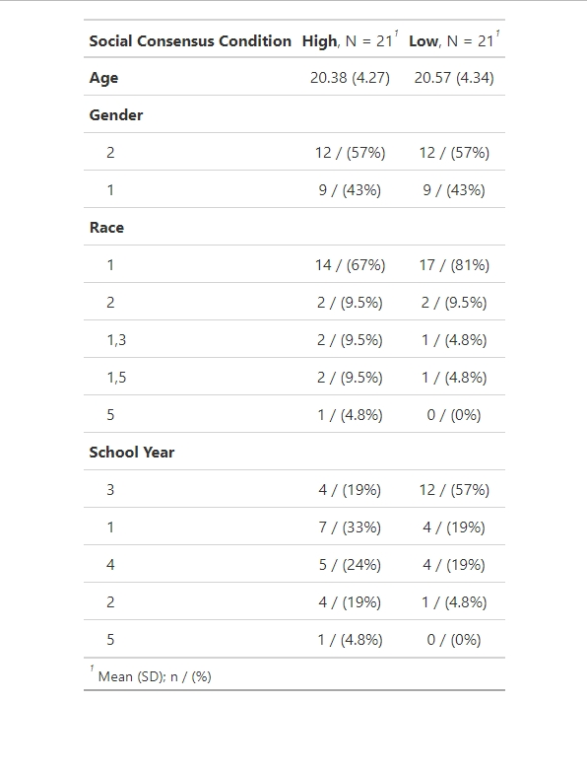

Procedure

Participants were randomly assigned to one of two conditions representing different exposure to social consensus. Our two conditions were a ‘High’ consensus condition (n=21) and a ‘Low’ consensus condition (n=21). The two conditions consisted of exposure to a modified series of surveys with three of the items taken from historical American public survey results (Economist – YouGov poll, 2017; Pew Research Polling, 2020) with a fourth item, on American support for the institution of slavery, chosen as a calibration item and attention check.

Biddle & Goold (2002). CHAT is a simulation exercise where participants construct their own HBP by allocating a limited set of resources to benefit types (e.g. dental) and choosing scope of coverage (basic-to-high). The HBP is represented by a ‘game board’ with several sections representing the different benefit types and with the scope of coverage represented by subdivisions in those sections. Each of these sections can be added to the HBP by paying a cost in points representative of its approximate relative cost in the US. For example, ‘basic’ dental care (regular cleanings and examinations every 6 months, with minimal dental care), costs 2 points; Upgrading to ‘medium’ dental care (everything in ‘basic,’ plus complete dental care including repairs and crowns), would cost 4 additional points, for a total cost of 6 points. Participants have a total of 47 points to use to design their HBP. Trade-offs are enforced as complete coverage is not possible with the limited resources. The core of the exercise is a simplified version of choosing priorities for a health care system.